LAB NO: 3

LAB AIM: To implement Find-S and Candidate Elimination Algorithms on the Enjoy Sports dataset and compare the generated hypotheses.

DATASET AND RESOURCES : Enjoy Dataset from classroom and Python/Jupyter Notebook

DATE OF PERFORMANCE:07 -08 -2026

GITHUB REPO LINK :
https://github.com/Prabhkirat-Singh-Marwah/ML-PRACTICALS/tree/main/Practical-03

This command imports libraries like pandas and numpy and reads the csv file named “enjoy”.

This command means that x will print everything except the last column and y will print only the last column.
We separate the data into X and y because the algorithm needs input and output separately.
X contains all the input columns except the last one.
y contains only the last column, which is the output.

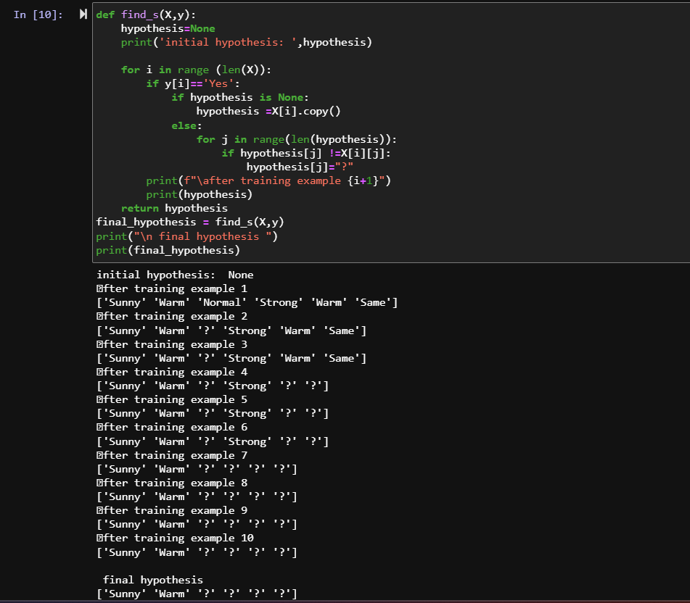
This command is the code for find-s .
In this , we find the positive value and compare it to other positive example, if the value matches we copy it and if it doesn’t, we write ? on it and continue this process till we get reach the final state.
This final state is the final output hypothesis for our code.

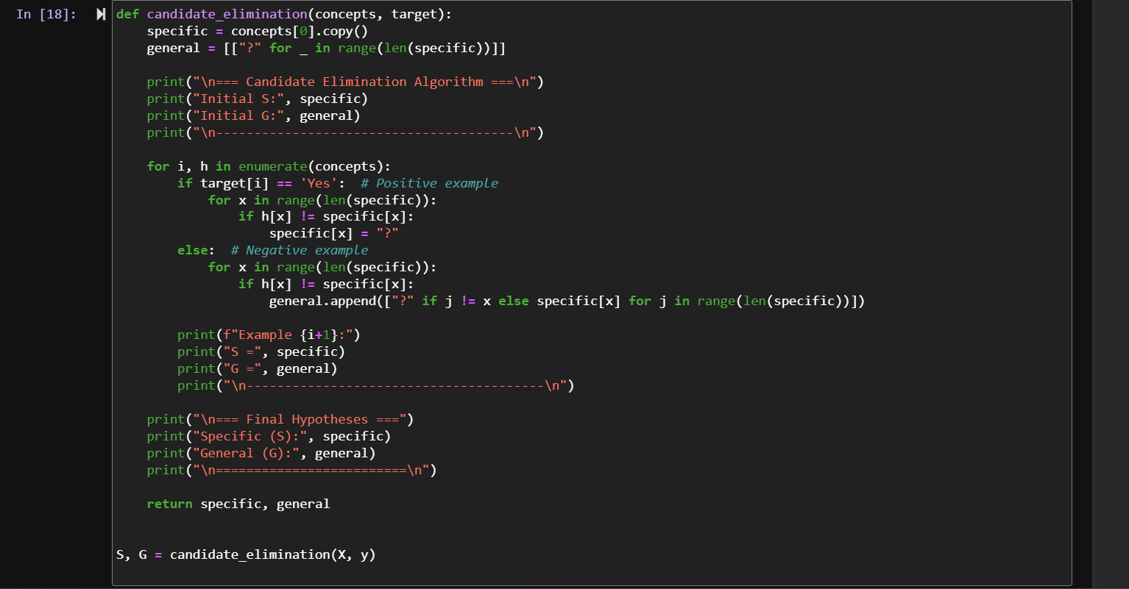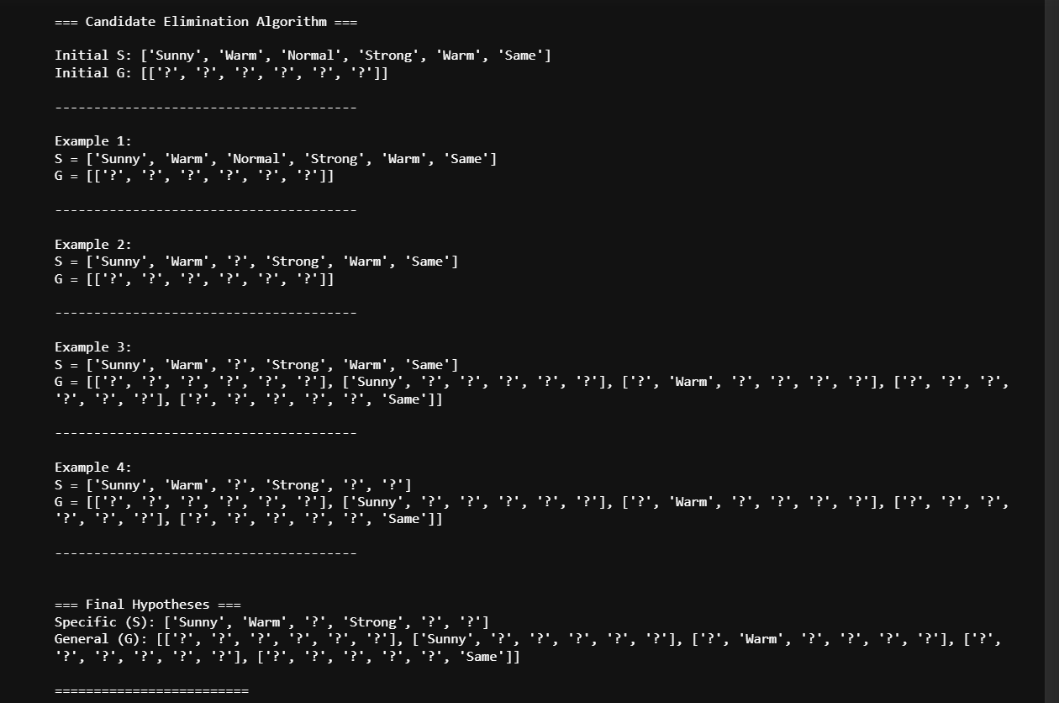
In this code, candidate elimination is performed.
Candidate Elimination maintains both a specific and a general hypothesis.
For Yes examples, it updates S, and for No examples, it updates G.
It checks all training examples and removes hypotheses that don't fit the data.
Finally, it gives the possible hypotheses between S and G.

VIVA QUESTIONS
1 What does df.iloc[:, :-1] do?
It selects all rows and all columns except the last column. We store these input values in X.
2 What does df.iloc[:, -1] do?
It selects all rows and only the last column. We store this output in y.
3 Why does the Find-S code check if y[i] == "Yes"?
Because Find-S only considers positive examples. It ignores the No examples while finding the hypothesis.
4 Why do we use hypothesis[j] = "?" in Find-S?
If two positive examples have different values for an attribute, it is changed to ?. ? means any value is acceptable.
5 In Candidate Elimination, why do we use target[i] == "Yes" and else?
For a Yes example, the code updates the specific hypothesis S. For a No example, it updates the general hypothesis G.

